Premiere Pro Project 6 S.E.T.
cenario: This project is focused on reviewing the Premiere Pro CC18 Tools and Interface prior to taking the ACA exam.
S

xpectation: Learn how to import an image sequence and review all tools
E

Timeline: It may take 5-6 hours of class time for students to complete this project.
INSERT AN SNIPPET OF YOUR PREMIERE PRO PROJECT 6 TEST SCORE HERE!!!!
If you have any difficulties, let me know and I’ll help!
80% or above is OK -

Premiere Pro Project 6 Worksheets
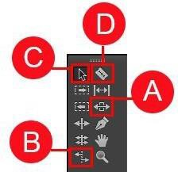

Use the diagram above to name and describe the Premiere Pro Tools

 | Name | Description
A.
B.
C.
D.

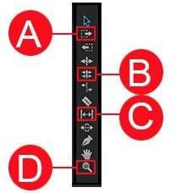

Use the diagram above to name and describe the Premiere Pro Tools

 | Name | Description
A.
B.
C.
D.

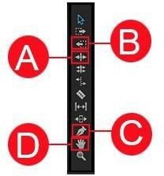

Use the diagram above to name and describe the Premiere Pro Tools

 | Name | Description
A.
B.
C.
D.

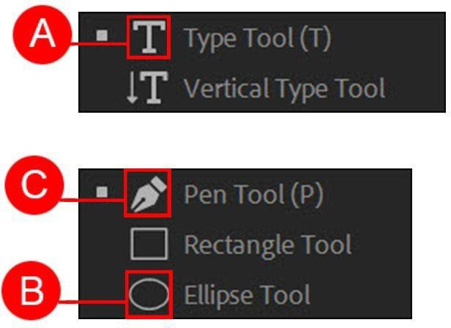

Use the diagram above to name and describe the Premiere Pro Tools

 | Name | Description
A.
B.
C.

