Project 5 – I Premiere Pro Project 5 S.E.T.
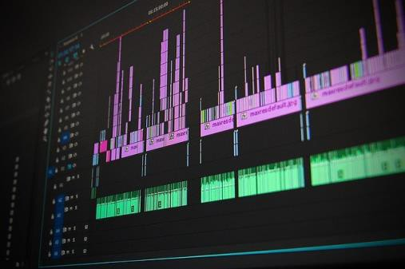
cenario: Part of getting an entry level job in the film/TV/Video Production industry is simply understanding the terminology and core concepts.
S
This series of videos and lessons will kick start your knowledge of this information

xpectation: Learn the film jargon, processes and concepts that will help you feel comfortable in an entry level job in the industry.
E

Timeline: It may take 3-5 hours of class time for students to complete this project.
INSERT AN SNIPPET OF YOUR PREMIERE PRO PROJECT 5 TEST SCORE HERE!!!!
If you have any difficulties, let me know and I’ll help!
80% or above is OK -

Premiere Pro Project 5 Worksheets

Copyright

Extension | Description
Intellectual Property
Fair Use
Creative Commons
Work for Hire
Derivative
Public Domain
Commercial Use
Attribution

Copyright Quizlet: https://quizlet.com/_2eatio NOT required, but helpful

Creative Commons Symbols
Creative Commons Quizlet: https://quizlet.com/_6v1fu0?x=1jqt&i=pmv66

Not required, but helpful.

Audio

Term | Description / add an image if possible
Ambient Sound
Foley Sound Effects
Dialog
Voice Over
Lapel Mic
Shotgun Mic
Hand Held Mic
Wireless

Audio Terms and Tools Quizlet: https://quizlet.com/_2edyxy

Not required, but helpful

Lighting

Lighting | Description Add images if possible
Three Point Lighting
Key Light
Fill Light
Back/Hair Light
Background Light
Cookie

Lighting Terminology Quizlet: https://quizlet.com/_2edzeb
Not required, but helpful

Shot Types

Shot Types | Description /Add an image if possible.
Long Shot (establishing)
Medium Shot
Close Up
Over the shoulder
POV
Rule of thirds
Low Angle
High Angle
Worms Eye
Pan
Tilt
Tracking
Cutaway
Coverage
Shot Types and Camera Moves Quizlet: https://quizlet.com/_2edz4

