Premiere Pro Project 4

Premiere Pro Project 4 S.E.T.
S
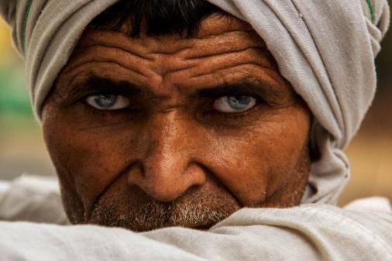
cenario: We often have people ask us to produce video slideshow for end of the season sports banquets, weddings, and funerals. In this project you will combine
a collection of photographs with some music.

xpectations: Learn how to organize images and then automate them onto the timeline based on timeline markers and apply position/scale keyframes to create
E
the Ken Burns pan/zoom effect.

Timeline: This mission may take a student 3-5 hours of class time to complete.

INSERT AN SNIPPET OF YOUR PREMIERE PRO PROJECT 4 TEST SCORE HERE!!!!
If you have any difficulties, let me know and I’ll help!
80% or above is OK -

Premiere Pro Project 4 Worksheets

NOTES: Using the BrainBuffet Project 4 tutorials, please answer the following questions.

- What documentary filmmaker is famous for his use of pan or zoom on still images?
  - Ken

- Which button automatically sends the group of selected media in the project bin to the timeline? It is often used to create
slideshows.

- What preference allows you to change the brightness of the Premiere Pro interface?

- What preference should you set prior to importing a bunch of photographs?

- What button is the key to creating a new sequence from scratch?

- What is the keyboard shortcut for adding a timeline marker?

- What do you call it when you adjust the sort order of media in the Project panel?

Premiere Pro Project 4 Specifications and Rubric

PREMIERE PRO PROJECT 4 SPECIFICATIONS
THIS IS WHAT YOU LEARNED WHEN YOU DID YOUR ASSIGNMENT
Screen Shot 1 - Timeline  ϒ Clip Markers (synced to music)  ϒ Photographs synced to markers  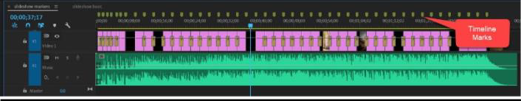 | Completed folder should have:  ϒ 1 screen shot  ϒ 1:45 second long .mp4 video file (see list below for expectations)  ϒ Student Packet 4  Video clip should demonstrate:  ϒ Photograph cuts to the beat of the music  ϒ At least two animated photos  ϒ Rolling Credits

These are NOT required, just ideas.

Extension Challenges:
- Practice Project Option 1: Scan some old family photos and make a music video for your grandparents.
- Practice Project Option 2: Collect a bunch of photographs for a local sports team and make an end of the season slideshow.

Cross-Curricular Enrichment:
- Language Arts - Make a slideshow for a book report
- Social Studies - Make a slideshow that illustrates key points in an event
- Science/Technology - Make a slideshow that illustrates a scientific concept like the water cycle

