Premiere Pro Project 3

Premiere Pro Project 3 S.E.T.
S
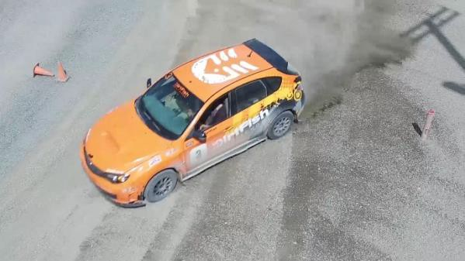
cenario: We got the chance to fly our drone over the local rally driving school and will be using this footage along with some green/blue screen clips
to make a short commercial for them.

xpectation: Learn how to composite using Green/Blue Screen, Blend Modes and Track Mattes. You will also get to import and animate a
E
multi-layered Premiere Profile.

Timeline: This should take you 6-10 hours of class time to complete.

INSERT AN SNIPPET OF YOUR PREMIERE PRO PROJECT 3 TEST SCORE HERE!!!!
If you have any difficulties, let me know and I’ll help!
80% or above is OK -

Premiere Pro Project 3 Worksheets

NOTES: Using the BrainBuffet Project 3 tutorials, please answer the following questions.

- Use the diagram above to name and describe the buttons in the Premiere Pro Color: Creative Panel
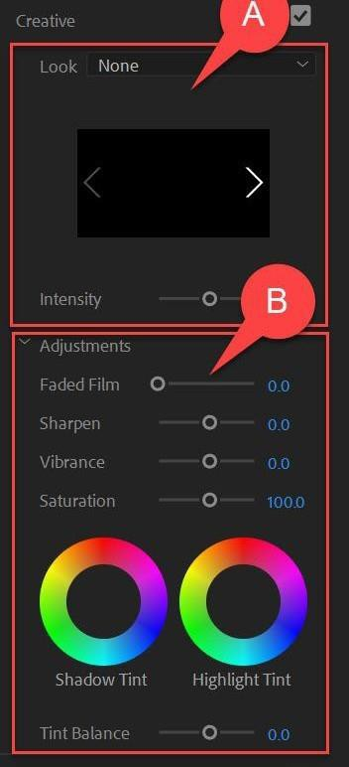
 | Name | Description
A.
B.

- What panel is used to control or adjust effects and keyframe your effects or visual elements?

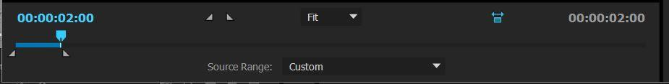
- How much of the sequence will you export based on the location of the In/Out points in this section of the Export Dialog box?

- What is the term for the process of combining a bunch of clips into a new sequence and then placing this into yet another sequence?

- What import option should you choose when you want to import a Premiere Profile and create a sequence with each of the Premiere Pro layers as individual tracks?

- What is the effect used to chromakey out a specific color?

- What is a quick way to hide parts of a video clip?

- What can you use to sync a couple clips?

- What is a fun way to blend a couple clips together?

- What effect will allow you to show video through a text layer?

- What panel can you use to generate volume keyframes based on clips being labeled Music or Dialog?

Premiere Pro Project 3 Specifications and Rubric

PREMIERE PRO PROJECT 3 SPECIFICATIONS
THIS IS WHAT YOU LEARNED WHEN YOU DID YOUR ASSIGNMENT
Media  Music, 2 Premiere Profiles, 3 green screen files, 9 video clips, text file with credit information  Tracks:  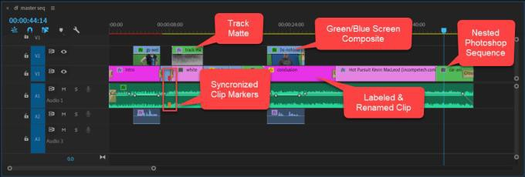 | Completed folder should have:  - Student Packet Project 3  - Timeline Screen Shot  - Dirtfish.mp4  Student should be able to:  - Animate an effect (blur)  - Use Blend Modes  - Create a track matte  - Composite clips using Ultra Key and opacity masks  - Nesting sequences  - Animating the position keyframes for a multi-layered Premiere Prosequence  - Rolling credits

These are NOT required, just ideas.

Premiere Pro Project 3 Enrichment
Project 3 Extension Challenges:
- Use your new editing skills to create a 30 second hype video for a club or sport. Make sure to great music that will be the core of your project and then get lots of interesting Broll shots to make the video entertaining.

Project 3 Cross-Curricular Enrichment:
- Language Arts: Make a short commercial for a book report
- Social Studies- Make a short commercial selling the idea of a war from the perspective of the ruler that is trying to convince their people the war is necessary
- Science/Technology- Make a short commercial that highlights the cool things that happen in

