N:_______________________________________________________ Date: _____________ Period: _________
Project 2 – Bike Interview

Premiere Pro Project 2

Premiere Pro Project 2 S.E.T.
S
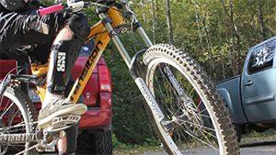
cenario: Our principal wants to produce short interviews of each teacher highlighting their
hobbies to help students relate to their
teachers. She has provided you with footage from a two camera interview and b roll of a bunch of mountain biking. Your job is to trim the interview down, add interesting b roll and a lower third title.

xpectation: Learn how to setup and edit a
E
multi-cam sequence, use lift/extract to edit on the timeline, control the speed of clips and create an animated lower third title.
Timeline: This may take a student 10-15 hours of class time to complete.
INSERT AN SNIPPET OF YOUR PREMIERE PRO PROJECT 2 TEST SCORE HERE!!!!
If you have any difficulties, let me know and I’ll help!
80% or above is OK -

Premiere Pro Project 2 Worksheets

NOTES: Using the BrainBuffet Project 2 tutorials, please answer the following questions.
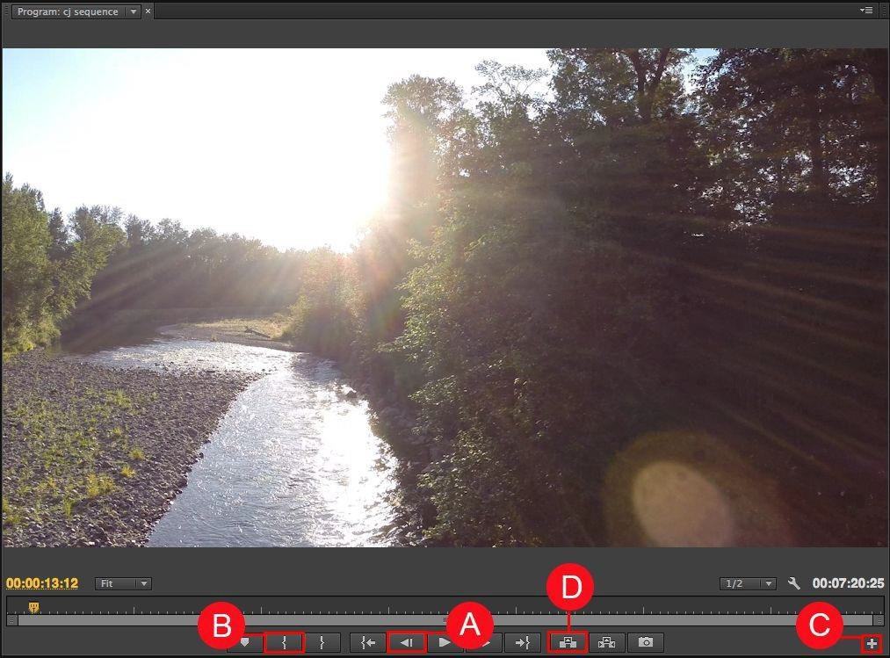

Use the diagram above to name and describe the buttons in the Premiere Pro Program Monitor

 | Name | Description
A.
B.
C.
D.

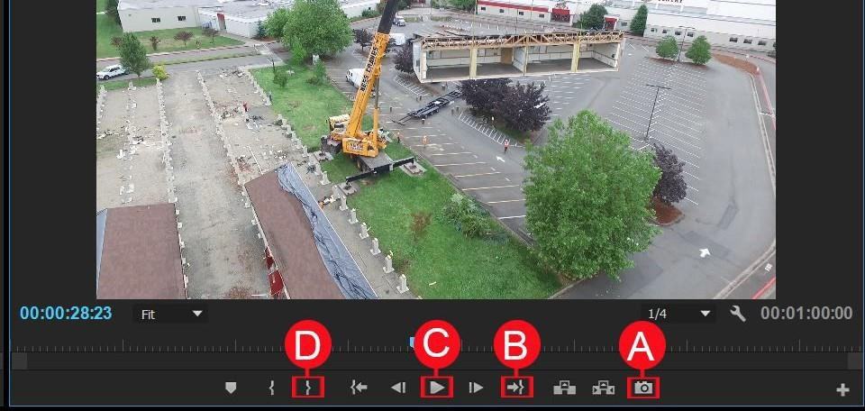

Use the diagram above to name and describe the buttons in the Premiere Pro Program Monitor

 | Name | Description
A.
B.
C.
D.

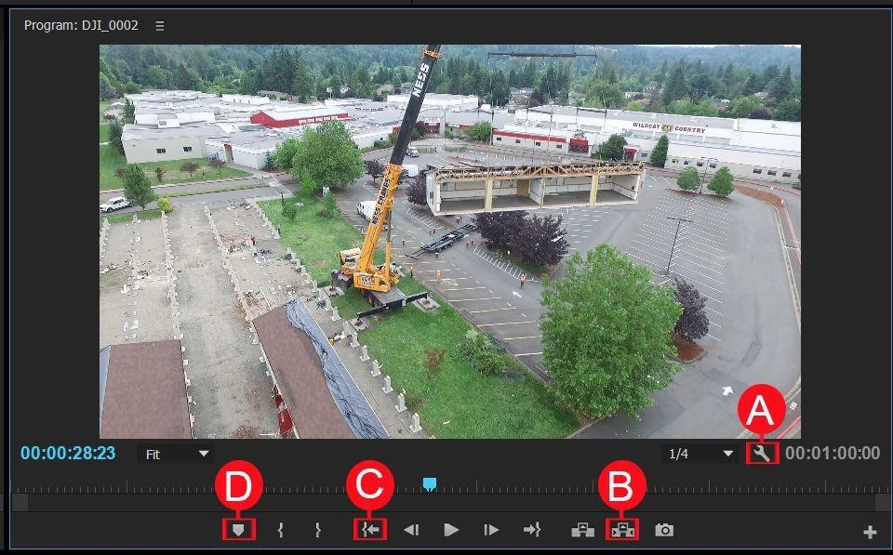

Use the diagram above to name and describe the buttons in the Premiere Pro Program Monitor

 | Name | Description
A.
B.
C.
D.

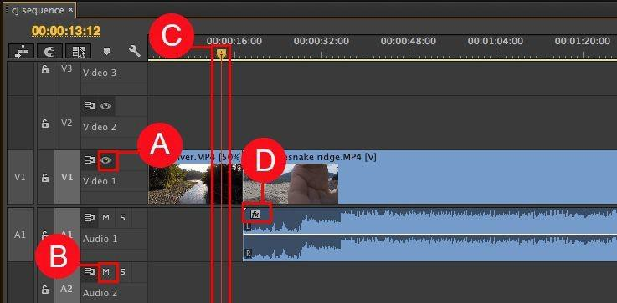

Use the diagram above to name and describe the features in the Premiere Pro Sequence Panel

 | Name | Description
A.
B.
C.
D.

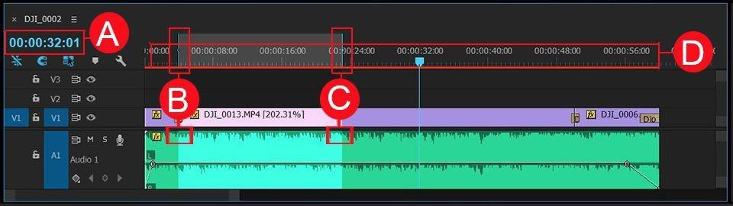

Use the diagram above to name and describe the features in the Premiere Pro Timeline Panel

 | Name | Description
A.
B.
C.
D.

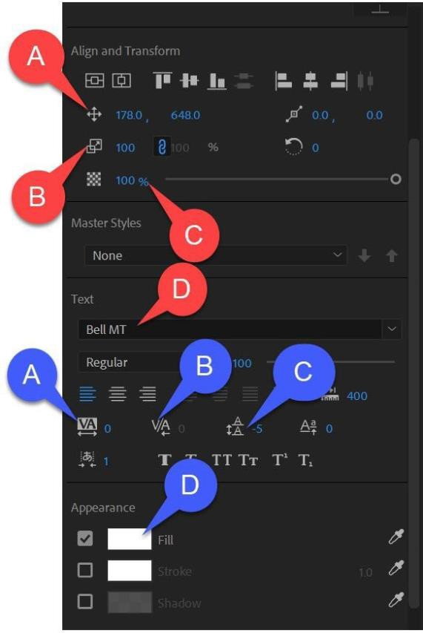
Use the diagram above to name and describe the features in the Premiere Pro Essential Graphics Panel

Red

 | Name | Description
A.
B.
C.
D.
Blue

 | Name | Description
A.
B.
C.
D.

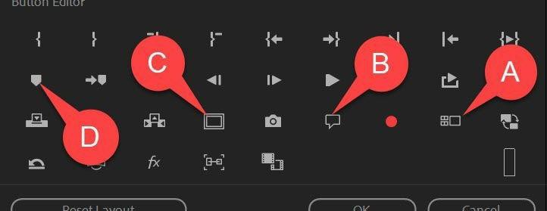

Use the diagram above to name and describe the features in the Premiere Pro Button Editor panel

 | Name | Description
A.
B.
C.
D.

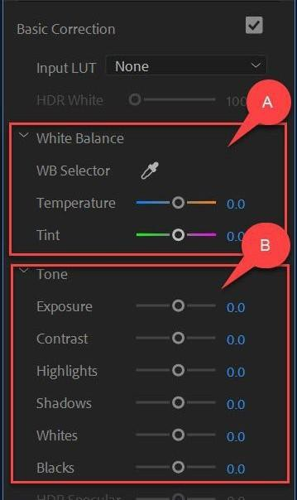

Use the diagram above to name and describe the features in the Premiere Pro Color: Basic Correction panel

 | Name | Description
A.
B.

Premiere Pro Project 2 Specifications

PREMIERE PRO PROJECT 2 SPECIFICATIONS
NOTHING TO DO HERE – THIS IS JUST WHAT YOU LEARNED
Screen Shot 1 - Timeline  ϒ Timeline Markers  ϒ Animated Lower Third  ϒ Adjustment Layer  ϒ Multi-cam clips on track 1  ϒ An L or J cut  ϒ Audio ducking keyframes on music track  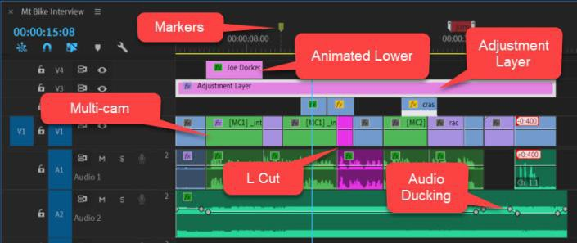  Exported Frame  ϒ A 1920 x 1080 .jpg file exported from the timeline  *Export a frame that includes the lower third  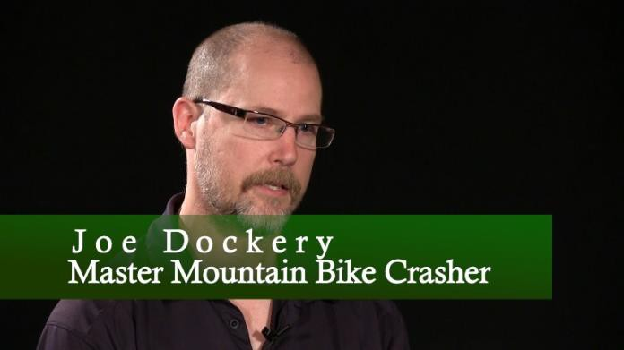 | Completed folder should have:  ϒ 1 screen shot  ϒ 1 Exported Frame  ϒ 30-60 second .mp4 video file (see list below for expectations)  Video clip should demonstrate:  ϒ Interview shots from both angles  ϒ Removed both “um” from the  interview  ϒ Animated lower third  ϒ Speed change on at least one clip  ϒ At least one “Freeze Frame”  ϒ Merge the audio and video clip “Get off the couch and get out and ride”  ϒ Adjustment layer with color grading applied

Premiere Pro Project 2

NOTHING TO DO HERE – THESE ARE OPTIONAL ASSIGNMENTS & POSSIBLY EXTRA CREDIT.

Project 2 Extension Challenges:

- Use your new editing skills to create a 1-3 minute video about your favorite hobby, club or sport at school, or an interesting person you know. Make sure to record a solid interview that will be the core of your project and then get lots of interesting B-roll shots to cover up your jump cuts and make the video more entertaining.

Project 2 Cross-Curricular Enrichment:
- Language Arts: Interview three teachers about the first book they remember reading and why it was important to them. Go to the library and record shots of someone turning the pages of these books
- Math- Record an interview of someone that uses math in their job, try to get shots of them doing it to use as b roll
- Social Studies- Interview someone from a local nursing home about local history and then shoot b roll of the topics they discuss
- Science/Technology- Record an interview of someone that uses science in their job, try to get shots of them doing it to use as b roll

