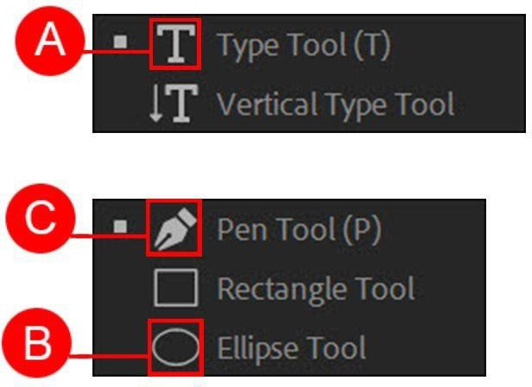
Name: ________________________________________________________ Date: _____________ Period: _________

ACATP ON Premiere Pro CC18|19
|20 GAMER Missi Handbook
Project 1 – Community Promo

Premiere Pro Project 1 S.E.T.

cenario: North Bend, Washington, a local city government wants to produce a 15 second promotional video they can post on their website. They have provided the video clips, voice over, text for titles and music. They need your help editing it together.
S
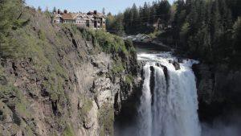
xpectations: Learn how to setup a Premiere Pro CC18 project and assembly a short video that includes multiple clips, music/voice over
E
and titles.

imeline: This should take you 5-6 hours of class time to complete.
T
INSERT AN SNIPPET OF YOUR PREMIERE PRO PROJECT 1 TEST SCORE HERE!!!!
If you have any difficulties, let me know and I’ll help!
80% or above is OK -

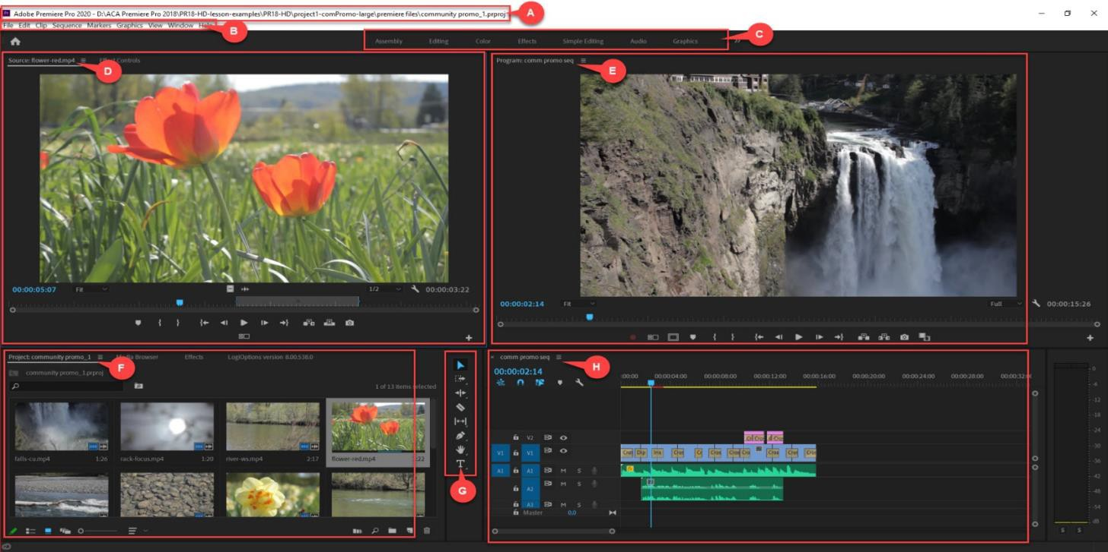

- Use the diagram above to name and describe the features in the Premiere Pro workspace

 | Name | Description
A.
B.
C.
D.
E.
F.
G.
H.

- File management is important so where should you save your Premiere Pro project file?

- What button in the “New Project” dialog box will allow you to select the location to save your Premiere Pro project file

- Where can you change the setting for how Premiere Pro deals with what it should do during start up (either “Show start screen” or “Open most recent” project)?

- What panel is used to control or adjust effects and keyframe your effects or visual elements

- Describe two ways can you create a new Sequence that will match the resolution/frame rate of your media

- What button will move a clip from the Source Monitor onto the timeline at the playhead/CTI and move the rest of the media down on the timeline?

- What do you call a title that moves horizontally across the screen?

- What do you call a title that moves vertically across the screen?

- How do you apply a transition between clips on the timeline?

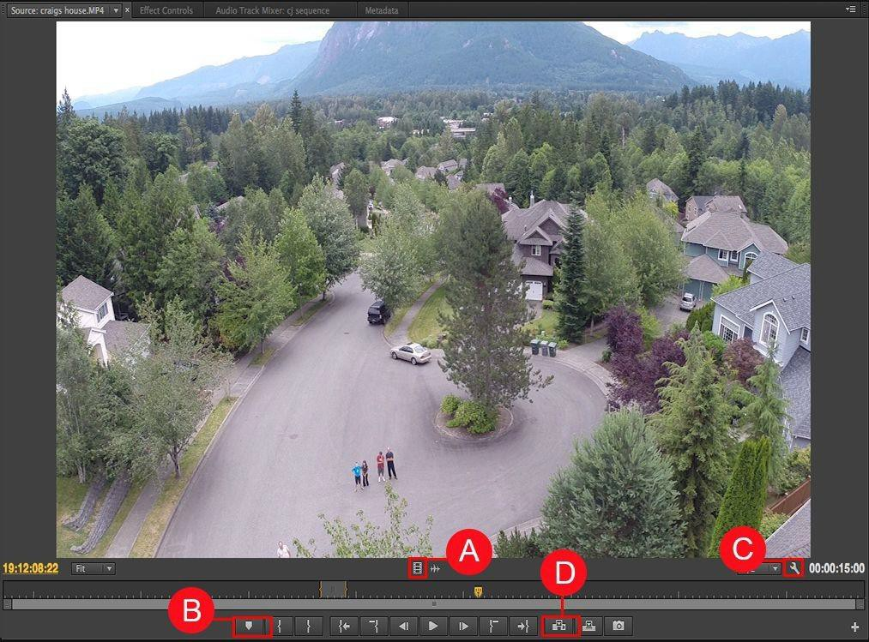

- Use the diagram above to name and describe the buttons in the Premiere Pro Source Monitor

 | Name | Description
A.
B.
C.
D.

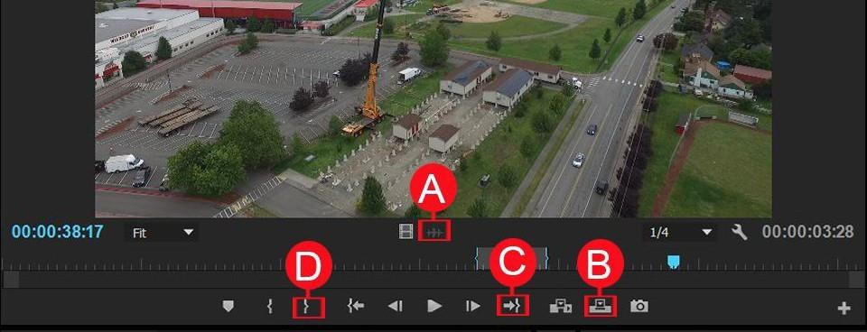

- Use the diagram above to name and describe the buttons in the Premiere Pro Source Monitor

 | Name | Description
A.
B.
C.
D.

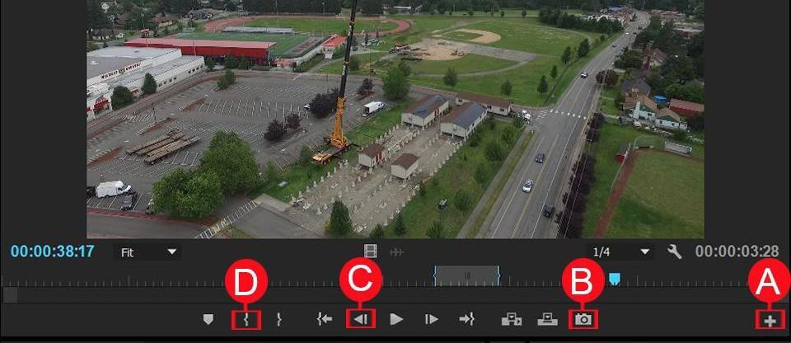

- Use the diagram above to name and describe the buttons in the Premiere Pro Source Monitor

 | Name | Description
A.
B.
C.
D.

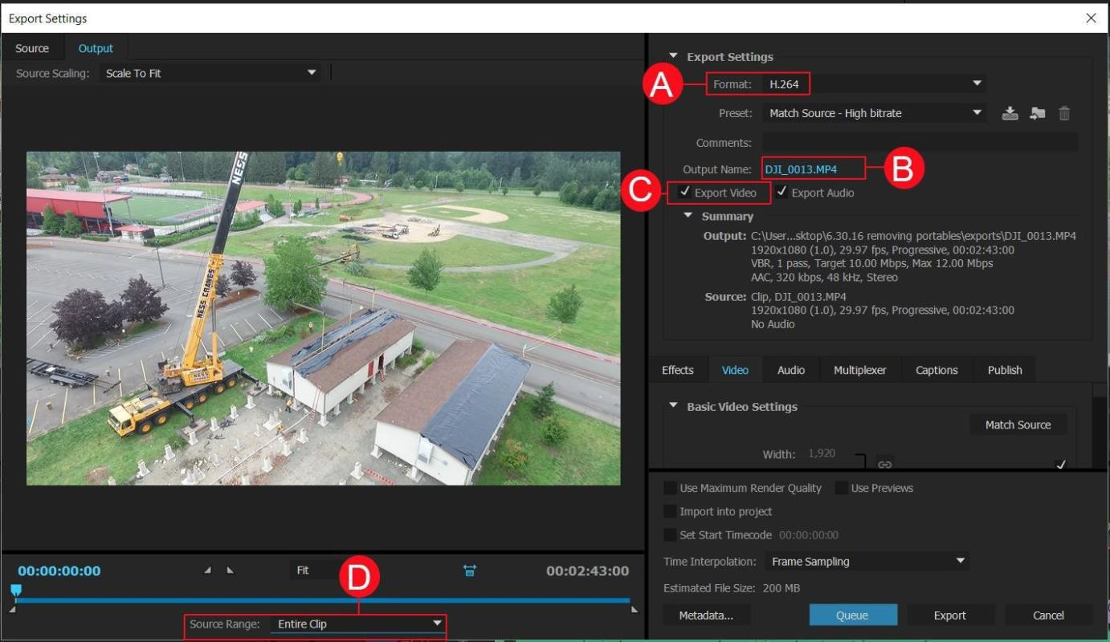

- Use the diagram above to name and describe the features in the Premiere Pro Export Dialog Box

 | Name | Description
A.
B.
C.
D.

Premiere Pro Project 1 Checklist and Rubric

SPECIFICATIO NS -
THIS IS WHAT YOU LEARNED WHEN YOU DID YOUR ASSIGNMENT
Screen Shot 1 - Workspace  ϒ File path meets your requirements  ϒ Workspace has limited panels  ϒ New Workspace on Workspace bar labeled  “Simple”  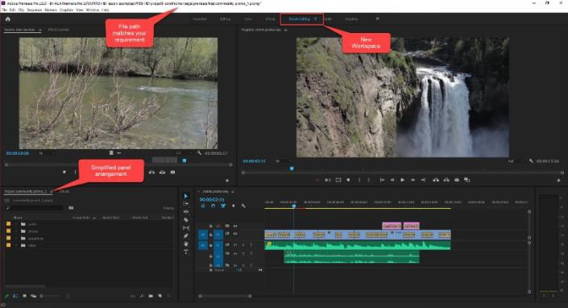  Screen Shot 2 – Project panel in list view  - Project panel in list view  - Bins for each type of media labeled correctly  - Bin for sequences with renamed sequence in it  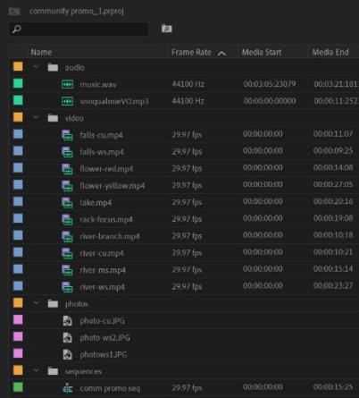 | Screen Shot 3 - Timeline  ϒ Renamed sequence  ϒ Two titles  ϒ 5-8 clips with transitions  ϒ Music clip with keyframes that lower the volume over the voice over  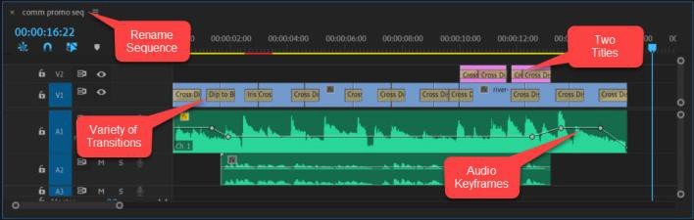  Completed folder should have:  - 3 screen shots  - 15 second .mp4 video file  Student should be able to:  - Organize media files and save their Premiere Pro file with the media files  - Import and organize media in the Project panel  - Create and rename a new sequence matching their media  - Use the source monitor to set in/out points and move to these clips to the timeline (insert/overwrite)  - Navigate and edit on the timeline using a variety of tools  - Create and edit simple titles  - Find and apply a variety of transitions  - Add audio clips and adjust volume using keyframes  - Export the completed projects

Adobe Premiere Pro- Essential Keyboard Shortcuts

Playback and Navigation
Spacebar | Play/Stop
Enter | Render
J, K, L | Rev, Play, Fwd
L/R Arrows | Move one frame -/+
+ | Zoom In
- | Zoom Out
Home | Move to Start
End | Move to End
Arrow Up | Move to Next Cut
Arrow Down | Move to Prev. Cut

Basic Editing Tools
V | Select Clip(s)
C | Razor Tool
B | Ripple Edit Tool
N | Roll Edit Tool
Y | Slip Edit Tool
U | Slide Edit Tool
X | Rate Stretch Tool
P | Pen Tool- keyframe

Advanced Editing Tools
M | Unnumbered Marker
Shift + select | Add to selection
Alt + drag | Unlink A/V
Ctrl +drag | Insert and Ripple
Comma | Insert Source
Period | Overlay Source
Ctrl-D | Add Default Trans.

Other – Fill in your personal favorites here

Premiere Pro Project 1 Extension Projects
These are NOT required, just ideas.

Project 1 Extension Challenges:
- Shoot footage around your community and produce your own community promo

Project 1 Cross-Curricular Enrichment:
- Language Arts: Record a voice over of a poem then shoot b roll that tells the story of the poem
- Math- Record a simple math problem and then shoot short clips that illustrate the concept
- Social Studies- Produce a one-minute video for your schools Veteran’s Day assembly
that includes a short voice over and some clips from https://archive.org/
- Science/Technology- Shoot some clips of an environmental concern in your community, record a short voice over and then edit it together

