L and J Cut Videos
In this project you will need to take two videos of what and L and J cut are. You will record yourself saying what an L and J cut are then put a video over yourself. The end video should be around 15 seconds with you on screen for ½ of the video with Intro and Outtros. 5 second intro, 5 seconds of you talking, 5 seconds of video over you talking, 5 second outro.
**This is a guide and probably not complete, listen in class for further instructions.
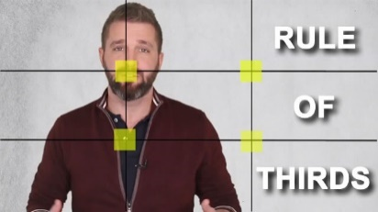
INSTRUCTIONS:
- SET UP RESOURCES
  - Make new folders (Audio, Premiere-Files, Video, Graphics) in your Premiere/PR-GMetrix folder
    - PR-02-L Cut
    - PR-02-J-Cut
  - Download a good video at https://www.pexels.com/videos/ (One for J and one for L cuts)
    - It doesn’t need to be related to your J or L cuts but find something interesting.
  - Copy and Paste a song into the Audio Folder (one for each video)
  - Research online what a L and J cuts are – you will be recording yourself saying what a L and J cut are. You can memorize what they are OR you can read it but memorizing would be better and more fluid.
- GENERAL INSTRUCTIONS:
  - Video
    - Record your J and L cut videos AT HOME – points will be deducted for recording at school/last minute.
      - Each (L and J cut should be around 10-15 seconds long.
      - I suggest you get someone to film you, but not mandatory.
      - Use Rule of Thirds (Text will be next to you as you speak. Put a colored box behind it so the text is more visible.
      - THINK about sound quality so make sure it’s quiet.
    - Send it to yourself FROM HOME. Please don’t send it to yourself in school, it takes too much time.
  - Intro - Add Animated Intro (Moving) with appropriate text (5 seconds) so the ducking song can be heard.
  - Credits - Add Animated Credits with text and your name. (5 seconds) so the ducking song can be heard.
  - Sound – Appropriate background sound file (Try to match the video’s energy)
    - You will need to use Auto Ducking for the audio OR generate your own keyframes.
  - Length – Variable but generally between 12 seconds and 20 seconds.
- GENERAL LOOK OF VIDEO - Feel Free do almost any style, BUT it might look like this:
  - Intro (5 seconds)
    - Quick description of a J/L-Cut with your name
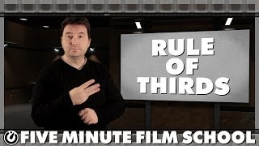
    - Music over that with ducking.
  - Video of you
    - Text to the side with L/J-Cut Information
  - Transition into
  - Video of B-Roll
  - Credits/Outro (5 seconds)
    - Name, etc.
  - Background music the entire video with Ducking under your voice.
  - Exported as 1280X720 video to Google Drive – Share with ALL

RUBRIC ON NEXT PAGE

GRADE
A | PREP – New folders created, resources (song and stock video) downloaded to correct folders, videos recorded and mailed to yourself from home, work in correct PR-02A-L or J Cut folder  REC – 10-15 second video with correct definition of L and J cuts.  Finished Video – Animated Intro/Outro, Ducking Music appropriate to scene, L and J cut with transitions completed properly.
B | PREP – Work in correct PR-02A-L or J Cut folder but not organized, videos recorded but class time used to mail videos.  REC – 7-12 second video with correct definition of L and J cuts.  Finished Video – Animated Intro/Outro, Ducking Music appropriate to scene, L and J cut with transitions completed properly.
C | PREP – Work in correct PR-02A-L or J Cut folder but not organized, videos recorded in school and class time used to mail videos.  REC – 7-12 second video with correct definition of L and J cuts. Portrait mode used.  Finished Video – Animated Intro/Outro, Ducking Music appropriate to scene, L and J cut with transitions completed properly completed but some issues with the video.
D | PREP – Work not organized, class time used to record and send videos  REC – 5-10 second video with correct definition of L and J cuts.  Finished Video – Video submitted but is improper format with poor Intro/Outro, ducking issues or no music, L and J cut poorly completed or incorrect definitions.
F | PREP – No videos, class time not used appropriately.  REC – No video or poor quality. second video with correct definition of L and J cuts.  Finished Video – No video submitted, improper format with no Intro/Outro, ducking issues or no music, L and J cut poorly completed or incorrect definitions. 50% OFF FOR ANY WORK TURNED IN AFTER 1 WEEK LATE.
39% | Hey, I tried but totally failed on it and have something – folders or audio to show you.
0% | No effort – didn’t try to make folders, no attempt.

